ST. XAVIER’S COLLEGE
(Affiliated to Tribhuvan University)
Maitighar, Kathmandu


LAB ASSIGNMENTS OF
SYSTEM ANALYSIS AND DESIGN
SUBMITTED BY:
Ayush Basnet
018BSCIT005

SUBMITTED TO:
ER. Rajan Karmacharya
Lecturer
Department of Computer Science

Draw a context diagram and level 0, level 1 and level 2 data flow diagram.
- Restaurant System
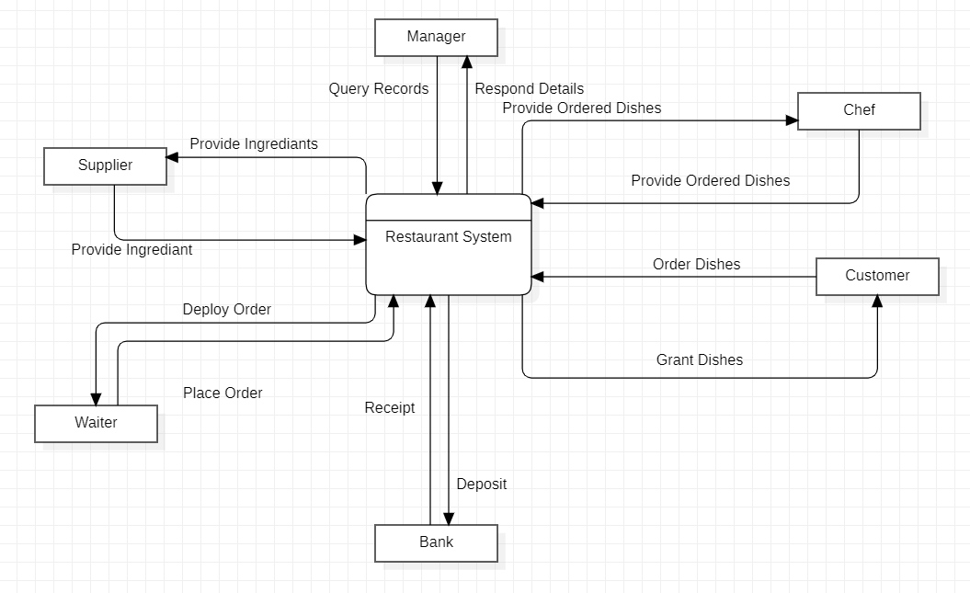
Fig: Context diagram
Entities:
- Manager
- Chef
- Supplier
- Waiter
- Customer
- Bank
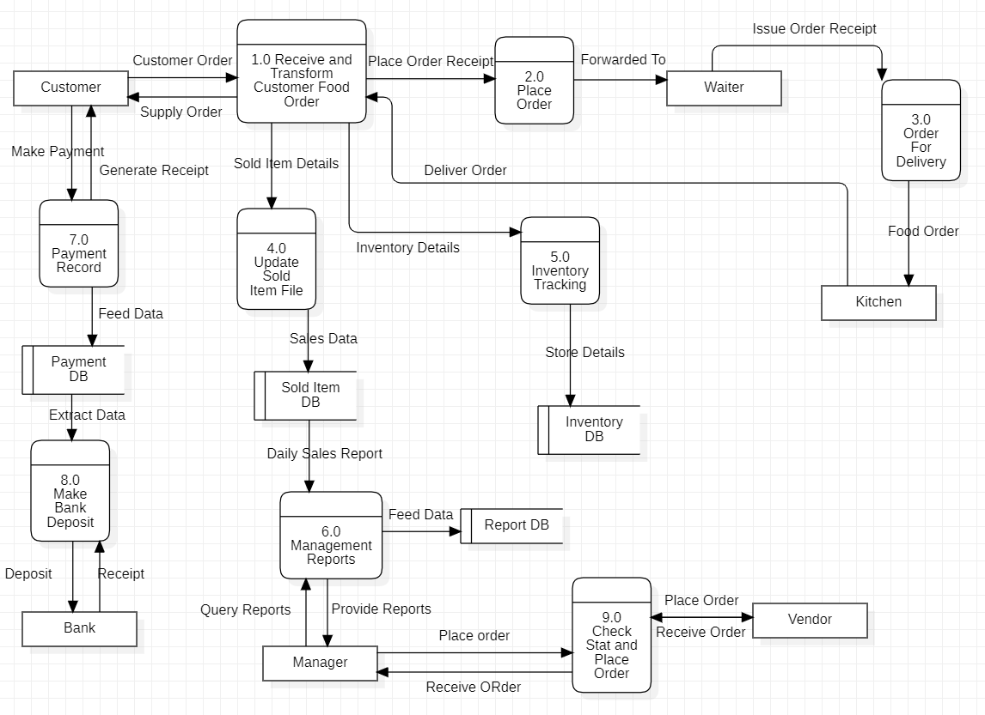
Fig: DFD - 0
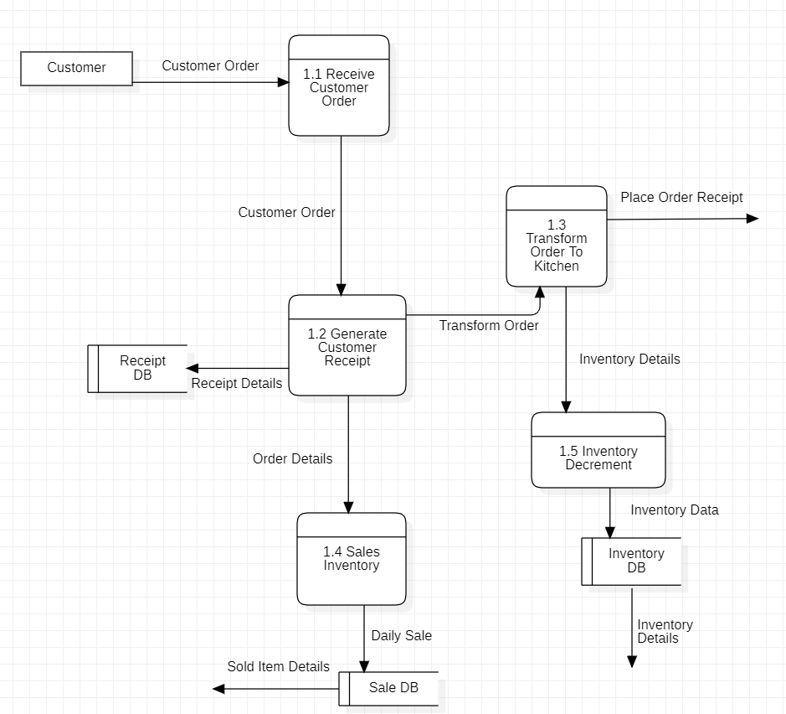
Fig: DFD - 1
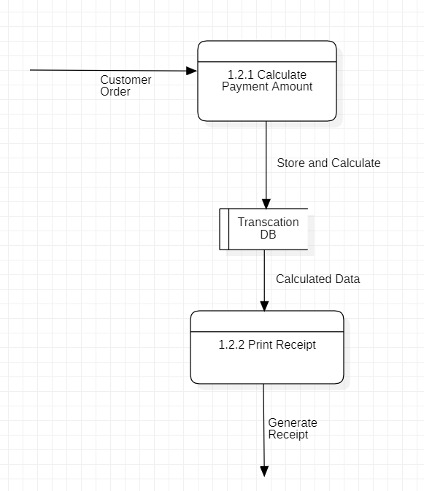
Fig: DFD - 2
2. Animal Park
The keepers in an animal park look after the feeding of the animals. Each animal is located in a
different areas of the park. Each area has its own keeper who reports to the head keeper.
The head-keeper maintains a record of the sorts of food that each animal species or type in the
park should be fed, and in what quantities. There is no distinction made between different
animals of the same species. The keepers access the information so they know what to feed
each animal type. Each animal type may be given more than one type of food, and each type of
food may be fed to a number of animal types. Each day the keepers will take out the food
needed for the animals in their care and record this on the information system. These food types
can be perishable or non-perishable according to their shelf life. For example, fresh fruit and
vegetables would be perishable where tinned produce or cereals would be considered to be
non-perishable.
The office staff keep a track of the food supplies. They monitor which foods are running low
every two or three days and draw up a list of that which needs to be ordered. In order to help
Then, the information system contains details about reorder quantities and re-order levels.
Sometimes they may need to readjust their re-order levels.
A number of suppliers are used, and their names, addresses and telephone numbers are kept in
the system. Because of the large quantities required and the difficulty of obtaining some foods
At certain times of the year, there is more than one possible supplier for each type of food. Most
The ordering is done via the telephone. A standard order form is then created. The order form
usually contains details of more than one food type to be ordered from a particular supplier. The
order also contains details of the date of the order and what quantities are required for each
food type.
When deliveries are received, the keepers check the delivery note against the goods received,
amend it if necessary and pass it onto the office. Here it is checked against the orders placed. It
they agree, this is recorded in the system. The office staff check the received orders against an
invoice sent by the supplier. If they agree, payment will be made. Any discrepancies are taken up with the supplier, and the supplier’s response is noted in the system. Most suppliers send an invoice each month.
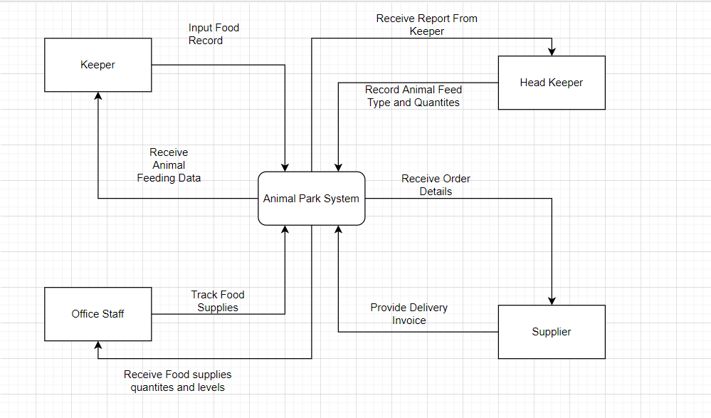
Fig: Context Diagram
Entities:
- Keeper
- Head Keeper
- Office Staff
- Supplier

There are four entities in the system. Keepers are responsible for feeding the animals by querying what to feed to which animal using the system. The Head Keeper generates reports from the system. The system sends an order form to the supplier, and after the supplies are sent, the supplier sends an invoice. The office staff is responsible for managing the stock details in the system.
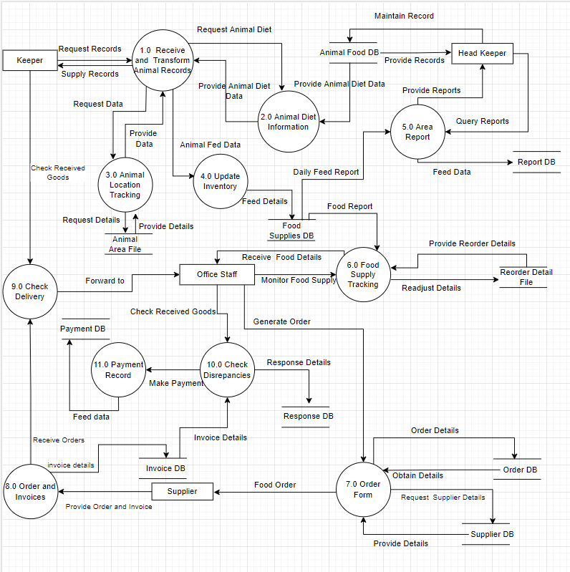
Fig: DFD-0
There are 9 processes in the DFD - 0 that make up the Animal Park System. It contains all of the processes and interactions that happen within the system. There are separate data stores for the Stocks, Invoices, and food the animals eat.
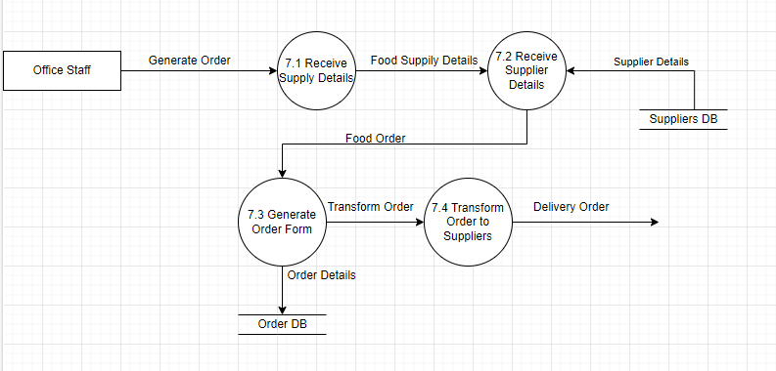
Fig: DFD-1
Process 7 “Order Form” is expanded into four sub-processes that receives, generates and transforms the order.
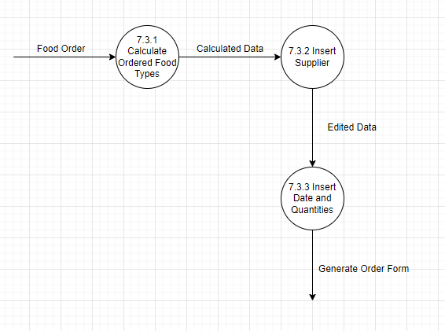
Fig: DFD-2
Process 7.3 “Generate Order Form” is divided into three subprocesses that consists of calculating and inserting data and quantities..
Video-Rental LTD case study
Video-Rental LTD is a small video rental store. The store lends videos to customers for a fee, and purchases its videos from a local supplier.
A customer wishing to borrow a video provides the empty box of the video they desire, their membership card, and payment – payment is always with the credit card used to open the customer account. The customer then returns the video to the store after watching it.
If a loaned video is overdue by a day the customer's credit card is charged, and a reminder letter is sent to them. Each day after that a further card is made, and each week a reminder letter is sent. This continues until either the customer returns the video, or the charges are equal to the cost of replacing the video.
New customers fill out a form with their personal details and credit card details, and the counter staff give the new customer a membership card. Each new customer's form is added to the customer file.
The local video supplier sends a list of available titles to Video-Rental LTD, who decide whether to send them an order and payment. If an order is sent then the supplier sends the requested videos to the store. For each new video a new stock form is completed and placed in the stock file.

Context diagram
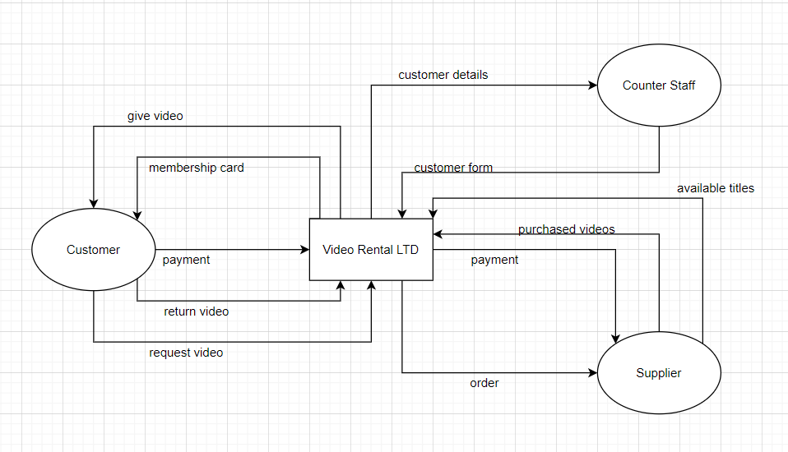
Entities:
- Customer
- Counter Staff
- Supplier

The customer sends the video details they want to rent and their payment details and after successful payment, the system responds with a receipt and rental details. The counter staff is responsible for entering new customer details into the system. The system sends the order for new video titles to the local supplier and the supplier fulfills that demand.
DFD Level 0
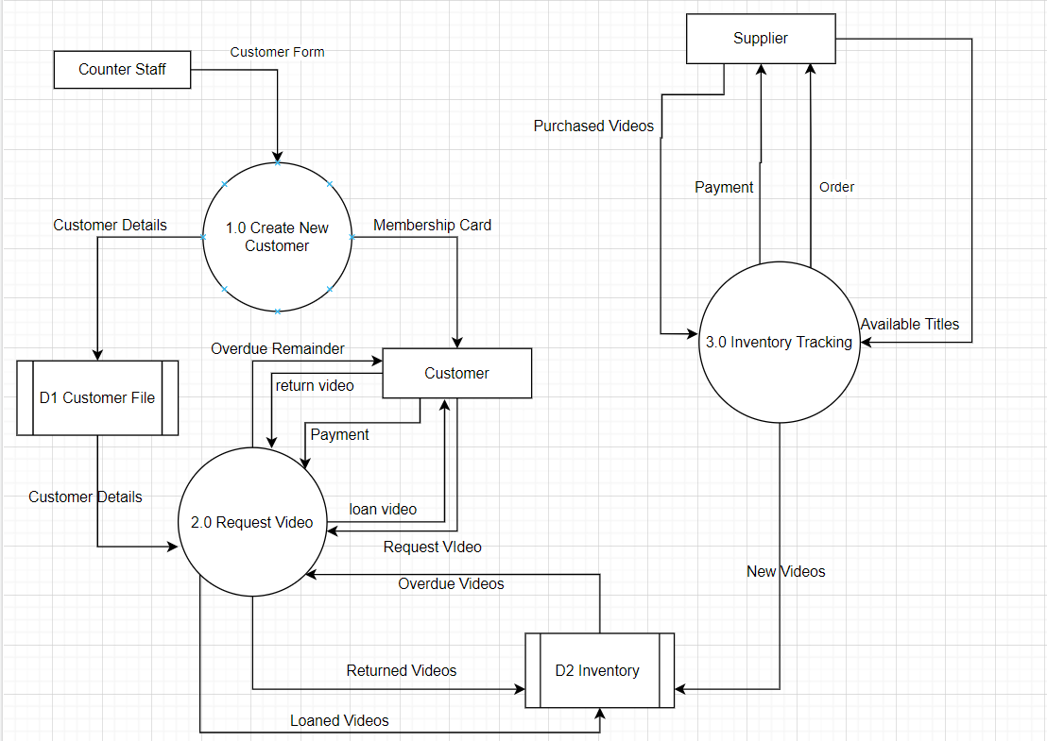

DFD Level 1
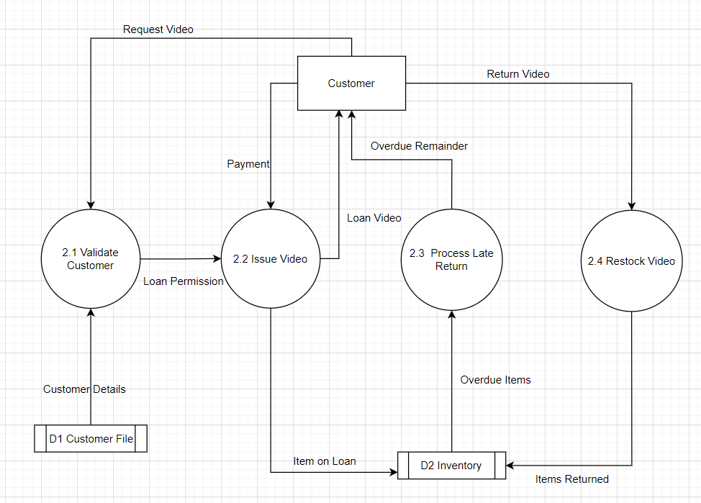
DFD Level 2
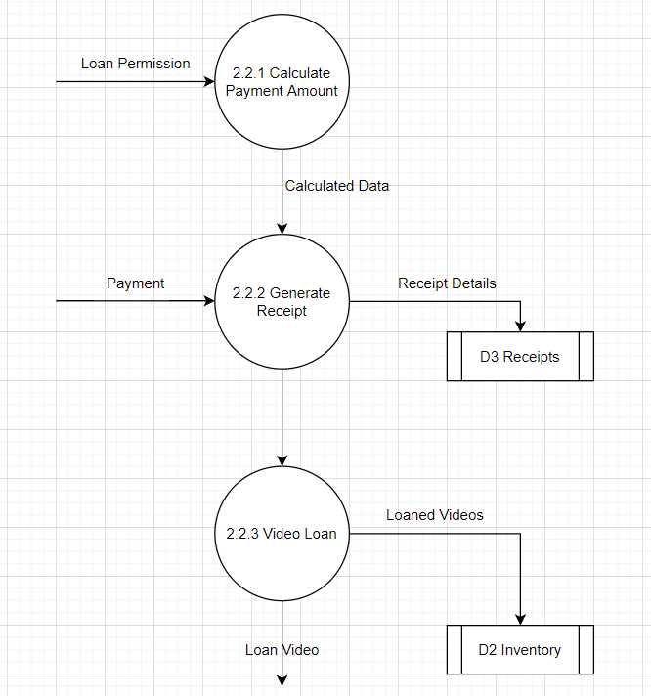
4. Perfect Pizza
Perfect pizza wants to install a system to record orders for pizza and chicken wings. When regular customers call Perfect Pizza on the phone, their phone number goes automatically into the Pizza system. The phone number invoked the name up on the screen. Once the order is taken, the total, including tax and delivery, is calculated. Then the order is given to the cook. A receipt is printed. Occasionally, special offer coupons are printed so the customer can get a discount. Drivers who make deliveries give customers a copy of the receipt and coupon if any. Weekly totals are kept for comparison with last year’s performance.
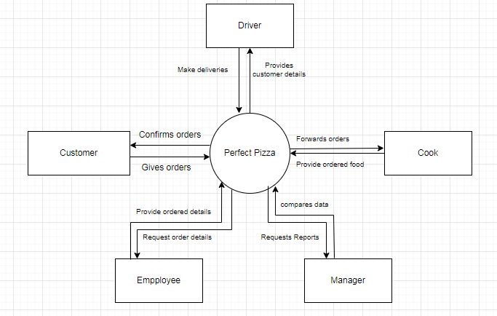
Fig: Context Diagram
Entities:
- Customer
- Driver
- Cook
- Employee
- Manager
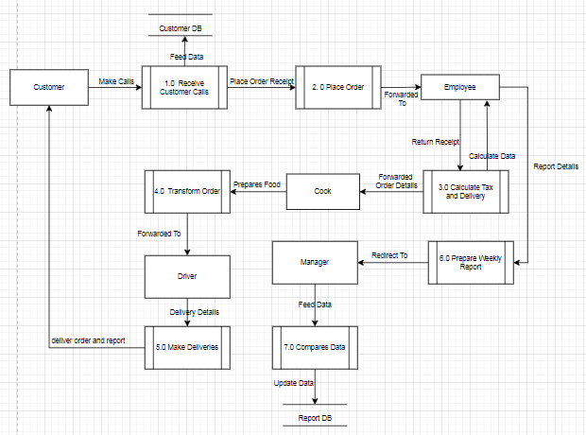
Fig: DFD - 0
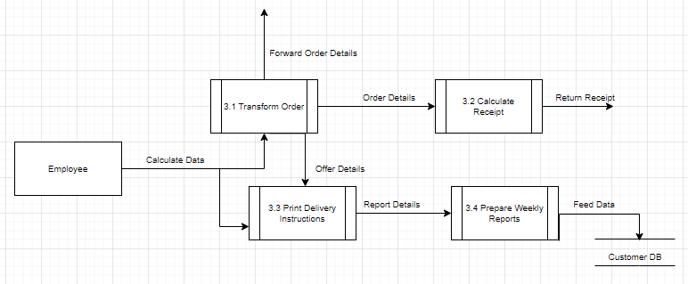
Fig: DFD - 1
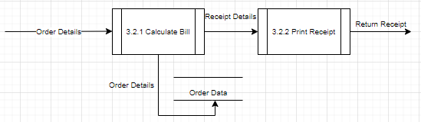
Fig: DFD - 2
Prepare a USE CASE diagram for
I. The Travel Agency Management System
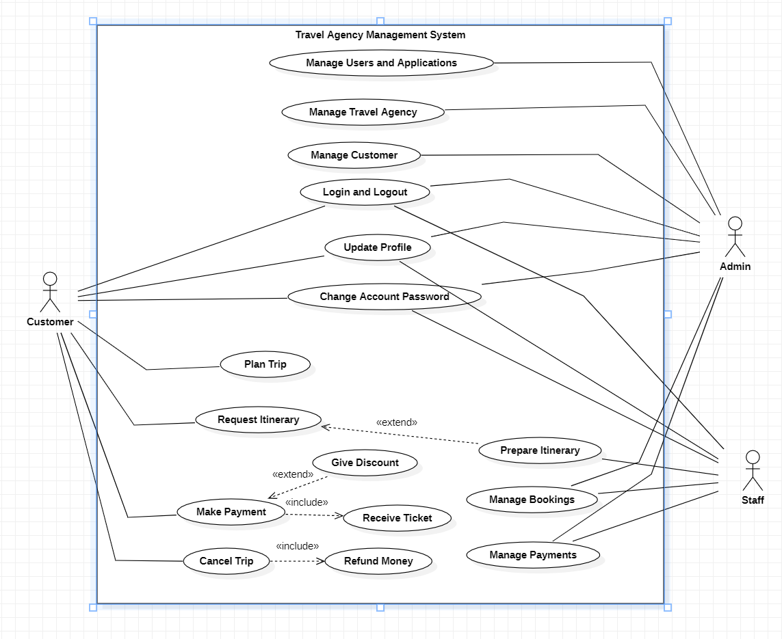
II. Simple ATM System
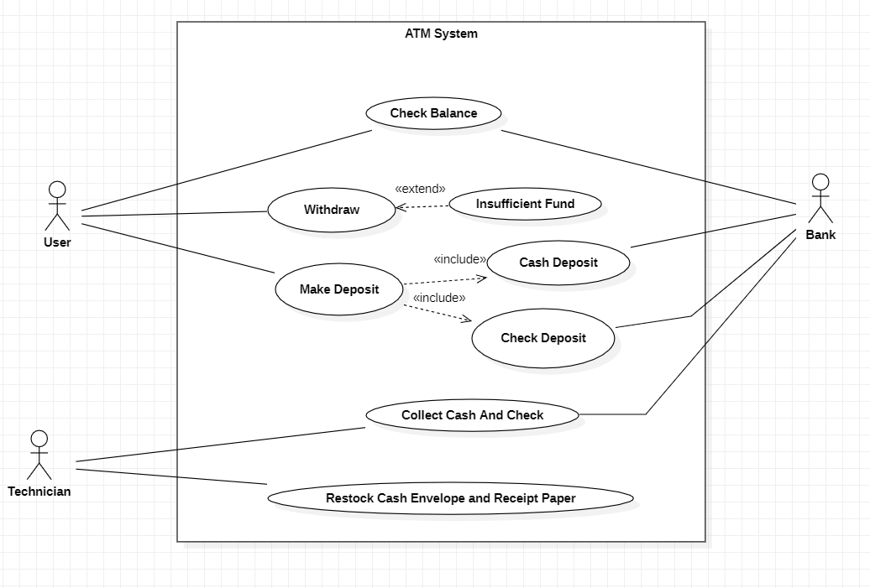

Construct the CPM Network.
1.
Activities | Precedents
A  B  C  D  E  F  G  H | -  -  A  A  B  B  D, E  F, G
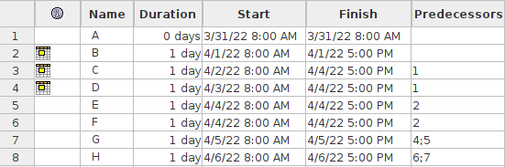
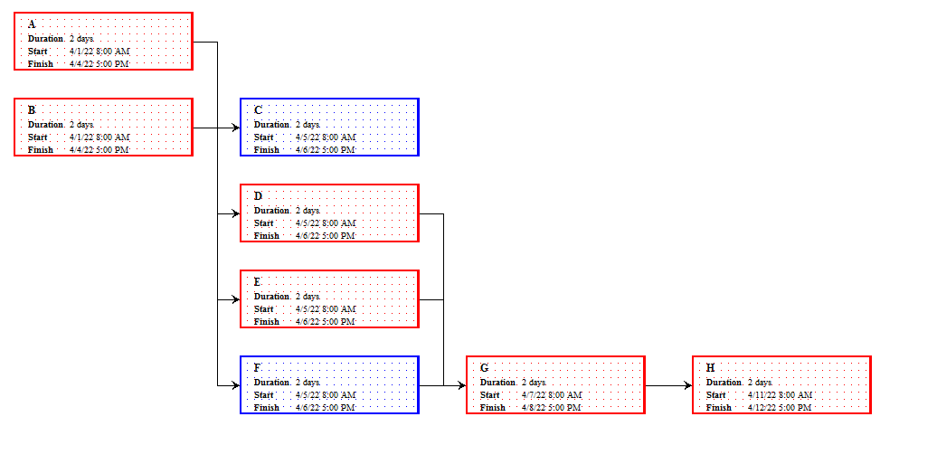

Activities | Precedents
A  B  C  D  E  F  G  H  I | -  -  A, B  A, B  B  D, E  C, F  D, E  G, H
